1. | The tables below show five points on the lines of two different linear equations.  Line 1  x y  1 3  2 5  3 7  4 9  5 11  Line 2  x y  1 15  2 13  3 11  4 9  5 7  Jenna concludes that (4, 9) is the solution to the system of these two equations. Which of the following justifies her conclusion?
 | A. The point (4, 9) appears in both tables.
 | B. Only these two lines contain the point (4, 9).
 | C. These two lines have the same rate of change.
 | D. These two lines are perpendicular to each other.

2. | The equations below represent the total amount charged, y, by two different plumbers as a function of the number of hours worked, x.  Plumber A:  Plumber B:  The graphs of these functions cross at the point (3, 120). What does the point (3, 120) signify?
 | A. The point (3, 120) is the slope of the system of equations.
 | B. The point (3, 120) is when the plumbers worked 120 hours.
 | C. The point (3, 120) is the y-intercept of the system of equations.
 | D. The point (3, 120) is the solution for the system of equations.

3. | A system of linear equations is graphed below.  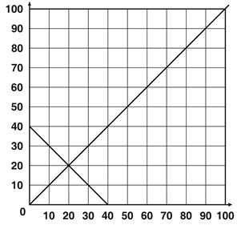  Which coordinate point represents the solution?
 | A. (2, 2)
 | B. (0, 40)
 | C. (40, 0)
 | D. (20, 20)

4. | The pair of linear equations 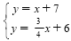 is graphed below.  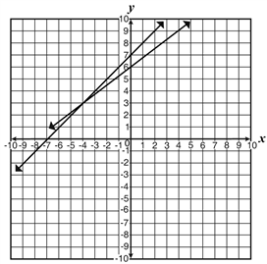  Which values for x and y will satisfy both linear equations?
 | A. x = 0, y = 7
 | B. x = – 7, y = 0
 | C. x = 3, y = – 4
 | D. x = – 4, y = 3

5. | The graph of a pair of linear equations is shown in the coordinate plane below.  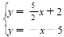  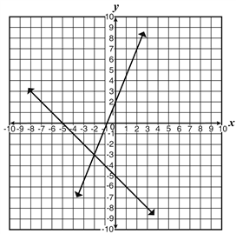  Which value is the x-coordinate of the solution?
 | A. – 5
 | B. – 3
 | C. – 2
 | D. 0

6. | The linear equations graphed in the coordinate plane below intersect.  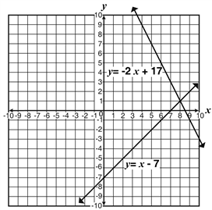  Which coordinate point is the solution?
 | A. (0, –7)
 | B. (1, 8)
 | C. (7, 0)
 | D. (8, 1)

7. | A linear system of equations is graphed below.  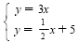  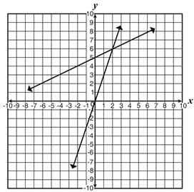  Which ordered pair is the solution to the system?
 | A. (0, 0)
 | B. (0, 5)
 | C. (2, 6)
 | D. (6, 2)

8. | A pair of linear equations is graphed below.  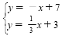  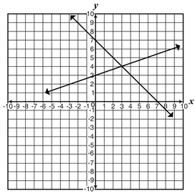  Which values for x and y would satisfy both of these equations?
 | A. x = 0, y = 3
 | B. x = 3, y = 4
 | C. x = 4, y = 3
 | D. x = 3, y = 7

9. | A system of linear equations is graphed below.  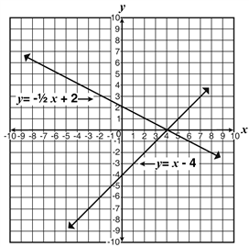  Which coordinate point represents the solution?
 | A. (0, 4)
 | B. (4, 0)
 | C. (0, – 4)
 | D. (4, – 4)

10. | The graphs and y = –2 are shown in the coordinate plane below.  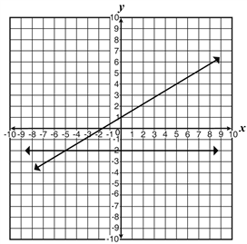  Which coordinate point satisfies both equations?
 | A. (–5, –2)
 | B. (–2, –5)
 | C. (–2, –2)
 | D. (0, –2)

11. | In the graph shown, which of the following values represents the x-value where line l and the line intersect?  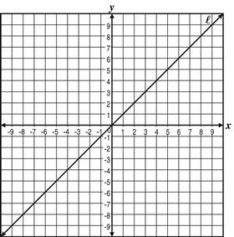
 | A.
 | B. 0
 | C. 1
 | D. 2

12. | Darren graphed the system of linear equations shown and determined that there is no possible solution.  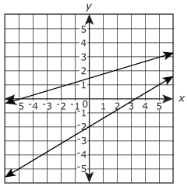  Which statement is true?
 | A. Darren is correct because the lines are parallel.
 | B. Darren is correct because both lines have different slopes.
 | C. Darren is incorrect because both lines have the same slope.
 | D. Darren is incorrect because the lines intersect at a single point.

13. | A system of linear equations is graphed on the coordinate grid shown.  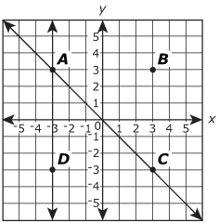  Which point represents the solution to the system?
 | A. Point A
 | B. Point B
 | C. Point C
 | D. Point D

14. | At which point do the graphs of the equations below intersect?  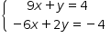
 | A.
 | B.
 | C.
 | D.

15. | What appears to be the solution to the system of equations shown in the graph below?  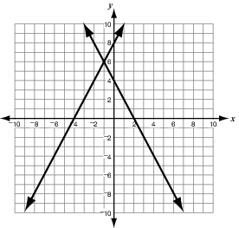
 | A.
 | B.
 | C.
 | D.

16. | At which point do the graphs of the equations shown below intersect?  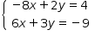
 | A.
 | B.
 | C.
 | D.

17. | What is the solution to the system of equations shown in the graph below?  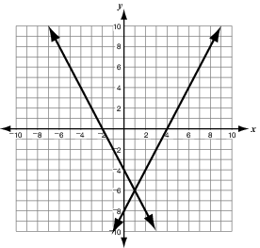
 | A.
 | B.
 | C.
 | D.

18. | At which point would the graphs of the equations below intersect?  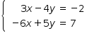
 | A.
 | B.
 | C.
 | D.

19. | Doris and Miguel are saving money weekly but at different rates. Doris and Miguel both write and graph equations to represent their savings. In both equations y represents the amount in savings account after x number of weeks. When the equations are graphed, the lines intersect at the point Which statement best explains the point of intersection?
 | A. Miguel will have $114 more than Doris after 6 weeks.
 | B. Doris will have $114 more than Miguel after 6 weeks.
 | C. Doris and Miguel will have the same amount after 6 weeks.
 | D. Doris and Miguel will have the same amount after 114 weeks.

20. | Which ordered pair is the solution of the linear system graphed below?  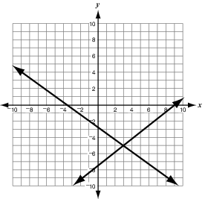
 | A.
 | B.
 | C.
 | D.

21. | At what point do the graphs of the lines intersect?
 | A.
 | B.
 | C.
 | D.

22. | Danisha represented a system of linear equations with the graph below.  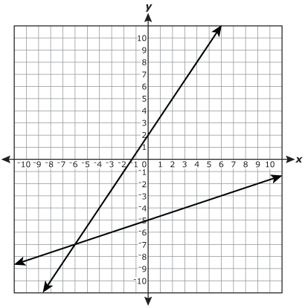  What is the solution to the system of equations?
 | A.
 | B.
 | C.
 | D.

