1. | Which statement BEST explains why the graphed relation is NOT a function?  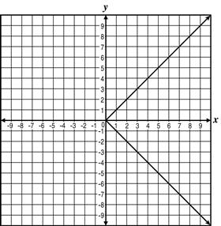
 | A. The graphed relation is not a line.
 | B. There are infinitely many points on the graph.
 | C. The domain of the graph does not include all real numbers.
 | D. There are points on the graph with the same x-coordinate but different y-coordinates.

2. | Which of the following is the graph of a function of x?
 | A.
 | B.
 | C.
 | D.

3. | Which of the following is NOT the graph of a function of x?
 | A.
 | B.
 | C.
 | D.

4. | Which graph is an example of a function?
 | A.
 | B.
 | C.
 | D.

5. | Which relation is a function?
 | A.
 | B.
 | C.
 | D.

6. | Which of the following graphs does NOT describe y as a function of x?
 | A.
 | B.
 | C.
 | D.

7. | Which ordered pair is a solution to the function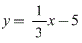?
 | A. (− 5, 3)
 | B. (− 4, 3)
 | C. (3, − 5)
 | D. (3, − 4)

8. | A linear function is graphed on the coordinate plane below.  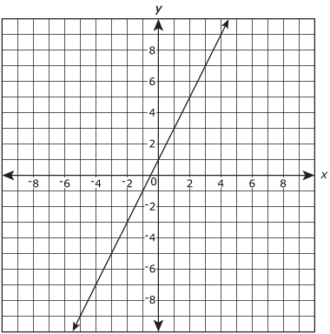  Which output value is associated with the input value of 4?
 | A. 1
 | B. 1.5
 | C. 2
 | D. 9

9. | Mary earns $7.25 an hour. She can determine her salary, s, for the number of hours she works, h, by using the equation s = 7.25h. Which statement explains why s is a function of h?
 | A. For every value of h there is only one value of s.
 | B. For some values of h there is more than one value of s.
 | C. For some values of s there is more than one value of h.
 | D. For every value of s there are two values of h.

10. | The relation shown is not a function.  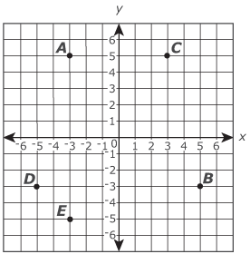  Which point should be removed to make the relation a function?
 | A. Point A
 | B. Point B
 | C. Point C
 | D. Point D

11. | Which relation could also represent a function?
 | A. {(3, 4), (0, 1), (−1, − 2), (−2, − 1), (0, − 1)}
 | B. y = x + 3
 | C.
 | D.

12. | Which of the following relations is a function?
 | A. {(− 1, − 4), (− 1, 0), (− 1, 5), (− 1, 7), (− 1, 9)}
 | B. {(− 2, − 4), (− 1, 7), (1, − 1), (1, 1), (3, 9)}
 | C. {(− 4, 9), (− 3, 1), (− 2, 3), (− 2, 12), (0, 6)}
 | D. {(0, − 4), (1, − 4), (2, 4), (3, 4), (4, − 4)}

13. | Which table represents a function?
 | A.
 | B.
 | C.
 | D.

14. | Which statement is true of table A and table B shown below?  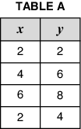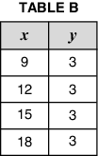
 | A. Table A represents a function because there is only one output for each input value.
 | B. Table B represents a function because there is only one output for each input value.
 | C. Table A represents a function because there is only one input for each output value.
 | D. Table B represents a function because there is only one input for each output value.

15. | Which of the equations shown below represents a function?  Equation 1 :  Equation 2 :
 | A. Only 1
 | B. Only 2
 | C. Both 1 and 2
 | D. Neither 1 nor 2

16. | Which set of ordered pairs does NOT represent a function?
 | A.
 | B.
 | C.
 | D.

17. | Which sets of ordered pairs below describe a function?  I.  II.  III.  IV.
 | A. I and II
 | B. II and III
 | C. III and IV
 | D. IV and I

18. | Sarah has been keeping track of how many hours she practices basketball each week and thinks that the percentage of free throws she makes during practice improves the more she practices. To check this, she makes a graph comparing the number of hours she practices each week with the percentage of free throws she makes each week. Based on what she learned in her Algebra class, she realizes that her graph represents a function. Which of these could be Sarah’s graph?
 | A.
 | B.
 | C.
 | D.

19. | Which function would also include the ordered pairs and
 | A.
 | B.
 | C.
 | D.

20. | Which of the following relations is not a function?
 | A.
 | B.
 | C.
 | D.

21. | Viola graphed the function on a coordinate plane. Which statement about this graph is true of all functions?
 | A. It is a linear graph.
 | B. It has a positive correlation.
 | C. It assigns a specific input to each output.
 | D. It assigns a unique output to each input.

22. | Which of these relations is NOT a function?
 | A.
 | B.
 | C.
 | D.

23. | The Juice Cafe posted the sign below showing the prices of smoothies of various sizes.  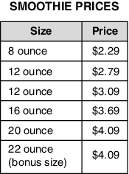  Which change would make the price of smoothies a function of the size?
 | A. change the smoothie prices so that each interval between prices is $0.50
 | B. change the first 12-ounce smoothie to a 10-ounce smoothie so that each smoothie size has only one price
 | C. change the price of the 22-ounce smoothie to $4.29 so that each price is assigned to only one smoothie size
 | D. change the 22-ounce smoothie to a 24-ounce smoothie so that each interval between smoothie sizes is 4 ounces

